Industry Grade Project 1: ABC Technologies
Build and Deploy Java Project using Maven and Git to Tomcat Container

Jenkins Job for Build and Deploy to Tomcat.
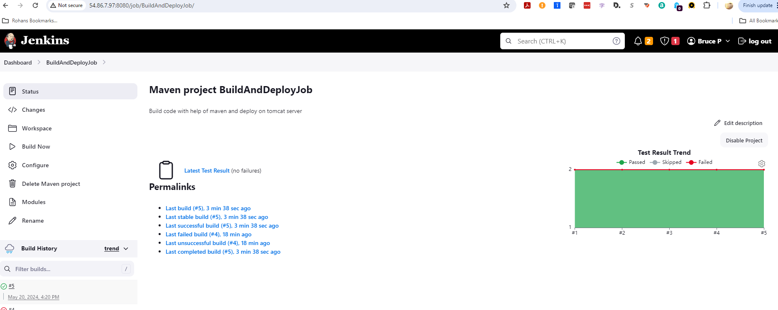

Configuration Details for source Git Repository
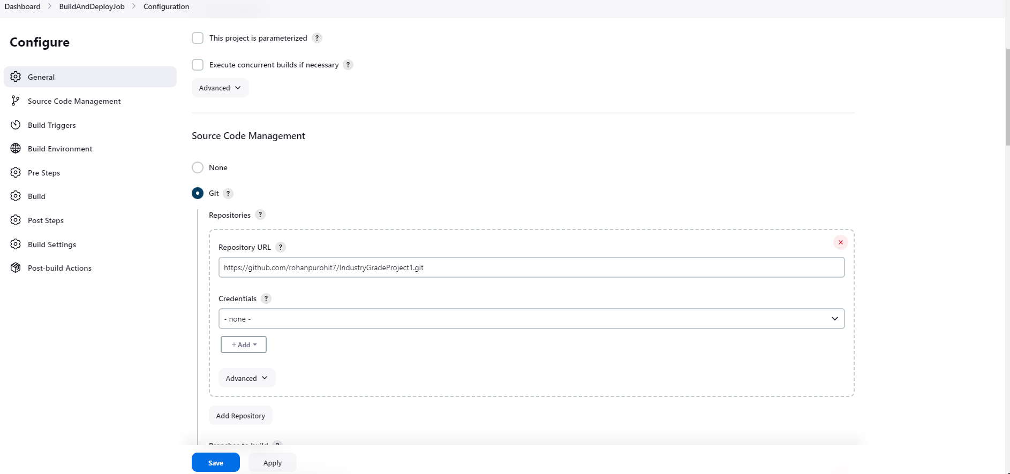

Build , Clean and Install Goals for POM
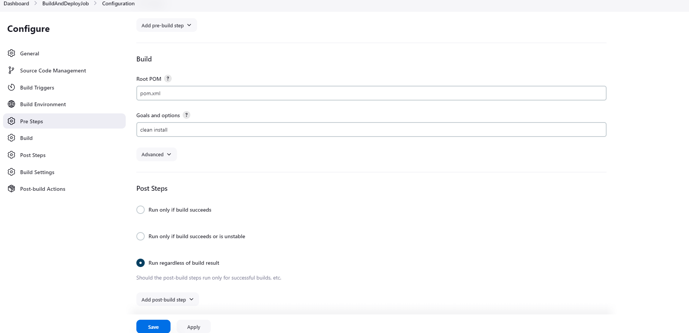

Deployer Role to deploy to Tomcat Container URL on WebApp Folder
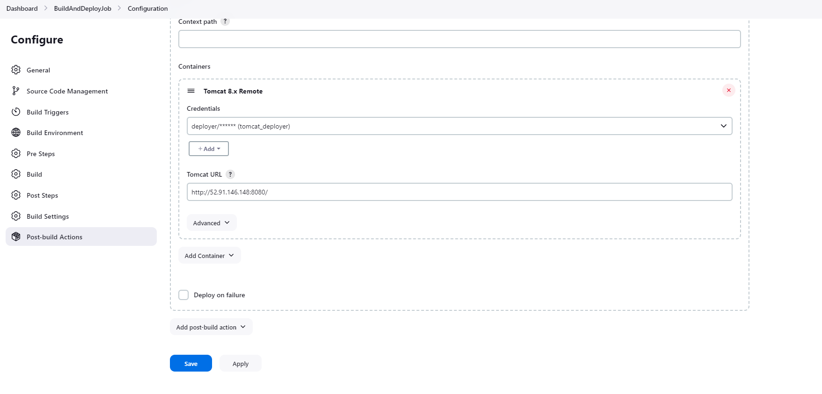

Successful Build Log for Build using Maven and Deploy to Tomcat Server.
Started by user Rohan P
Running as SYSTEM
Building in workspace /var/lib/jenkins/workspace/BuildAndDeployJob
The recommended git tool is: NONE
No credentials specified
> git rev-parse --resolve-git-dir /var/lib/jenkins/workspace/BuildAndDeployJob/.git # timeout=10
Fetching changes from the remote Git repository
> git config remote.origin.url https://github.com/rohanpurohit7/IndustryGradeProject1.git # timeout=10
Fetching upstream changes from https://github.com/rohanpurohit7/IndustryGradeProject1.git
> git --version # timeout=10
> git --version # 'git version 2.40.1'
> git fetch --tags --force --progress -- https://github.com/rohanpurohit7/IndustryGradeProject1.git +refs/heads/*:refs/remotes/origin/* # timeout=10
> git rev-parse refs/remotes/origin/master^{commit} # timeout=10
Checking out Revision 2da8416d5e01e0ce16ff606083bf53f601892880 (refs/remotes/origin/master)
> git config core.sparsecheckout # timeout=10
> git checkout -f 2da8416d5e01e0ce16ff606083bf53f601892880 # timeout=10
Commit message: "new break line for password field in index.jsp"
> git rev-list --no-walk 2da8416d5e01e0ce16ff606083bf53f601892880 # timeout=10
Parsing POMs
Established TCP socket on 40777
[BuildAndDeployJob] $ /usr/lib/jvm/java/bin/java -cp /var/lib/jenkins/plugins/maven-plugin/WEB-INF/lib/maven35-agent-1.14.jar:/opt/maven/boot/plexus-classworlds-2.7.0.jar:/opt/maven/conf/logging jenkins.maven3.agent.Maven35Main /opt/maven /var/cache/jenkins/war/WEB-INF/lib/remoting-3160.vd76b_9ddd10cc.jar /var/lib/jenkins/plugins/maven-plugin/WEB-INF/lib/maven35-interceptor-1.14.jar /var/lib/jenkins/plugins/maven-plugin/WEB-INF/lib/maven3-interceptor-commons-1.14.jar 40777
<===[JENKINS REMOTING CAPACITY]===>channel started
Executing Maven: -B -f /var/lib/jenkins/workspace/BuildAndDeployJob/pom.xml clean install
[INFO] Scanning for projects...
[WARNING]
[WARNING] Some problems were encountered while building the effective model for com.example.maven-project:server:jar:1.0-SNAPSHOT
[WARNING] Reporting configuration should be done in <reporting> section, not in maven-site-plugin <configuration> as reportPlugins parameter.
[WARNING]
[WARNING] Some problems were encountered while building the effective model for com.example.maven-project:webapp:war:1.0-SNAPSHOT
[WARNING] Reporting configuration should be done in <reporting> section, not in maven-site-plugin <configuration> as reportPlugins parameter.
[WARNING]
[WARNING] Some problems were encountered while building the effective model for com.example.maven-project:maven-project:pom:1.0-SNAPSHOT
[WARNING] Reporting configuration should be done in <reporting> section, not in maven-site-plugin <configuration> as reportPlugins parameter. @ line 58, column 24
[WARNING]
[WARNING] It is highly recommended to fix these problems because they threaten the stability of your build.
[WARNING]
[WARNING] For this reason, future Maven versions might no longer support building such malformed projects.
[WARNING]
[WARNING] The project com.example.maven-project:maven-project:pom:1.0-SNAPSHOT uses prerequisites which is only intended for maven-plugin projects but not for non maven-plugin projects. For such purposes you should use the maven-enforcer-plugin. See https://maven.apache.org/enforcer/enforcer-rules/requireMavenVersion.html
[INFO] ------------------------------------------------------------------------
[INFO] Reactor Build Order:
[INFO]
[INFO] Maven Project [pom]
[INFO] Server [jar]
[INFO] Webapp [war]
[INFO]
[INFO] --------------< com.example.maven-project:maven-project >---------------
[INFO] Building Maven Project 1.0-SNAPSHOT [1/3]
[INFO] from pom.xml
[INFO] --------------------------------[ pom ]---------------------------------
[INFO]
[INFO] --- clean:3.2.0:clean (default-clean) @ maven-project ---
[INFO]
[INFO] --- install:3.1.1:install (default-install) @ maven-project ---
[INFO] Installing /var/lib/jenkins/workspace/BuildAndDeployJob/pom.xml to /var/lib/jenkins/.m2/repository/com/example/maven-project/maven-project/1.0-SNAPSHOT/maven-project-1.0-SNAPSHOT.pom
[INFO]
[INFO] ------------------< com.example.maven-project:server >------------------
[INFO] Building Server 1.0-SNAPSHOT [2/3]
[INFO] from server/pom.xml
[INFO] --------------------------------[ jar ]---------------------------------
[INFO]
[INFO] --- clean:3.2.0:clean (default-clean) @ server ---
[INFO] Deleting /var/lib/jenkins/workspace/BuildAndDeployJob/server/target
[INFO]
[INFO] --- resources:2.5:resources (default-resources) @ server ---
[debug] execute contextualize
[INFO] Using 'utf-8' encoding to copy filtered resources.
[INFO] skip non existing resourceDirectory /var/lib/jenkins/workspace/BuildAndDeployJob/server/src/main/resources
[INFO]
[INFO] --- compiler:2.3.2:compile (default-compile) @ server ---
[INFO] Compiling 1 source file to /var/lib/jenkins/workspace/BuildAndDeployJob/server/target/classes
[INFO]
[INFO] --- resources:2.5:testResources (default-testResources) @ server ---
[debug] execute contextualize
[INFO] Using 'utf-8' encoding to copy filtered resources.
[INFO] skip non existing resourceDirectory /var/lib/jenkins/workspace/BuildAndDeployJob/server/src/test/resources
[INFO]
[INFO] --- compiler:2.3.2:testCompile (default-testCompile) @ server ---
[INFO] Compiling 1 source file to /var/lib/jenkins/workspace/BuildAndDeployJob/server/target/test-classes
[INFO]
[INFO] --- surefire:2.11:test (default-test) @ server ---
[INFO] Surefire report directory: /var/lib/jenkins/workspace/BuildAndDeployJob/server/target/surefire-reports

-------------------------------------------------------
T E S T S
-------------------------------------------------------
Running com.example.TestGreeter
Tests run: 2, Failures: 0, Errors: 0, Skipped: 0, Time elapsed: 0.181 sec

Results :

Tests run: 2, Failures: 0, Errors: 0, Skipped: 0

[JENKINS] Recording test results
[INFO]
[INFO] --- jar:3.3.0:jar (default-jar) @ server ---
[INFO] Building jar: /var/lib/jenkins/workspace/BuildAndDeployJob/server/target/server.jar
[INFO]
[INFO] --- install:3.1.1:install (default-install) @ server ---
[INFO] Installing /var/lib/jenkins/workspace/BuildAndDeployJob/server/pom.xml to /var/lib/jenkins/.m2/repository/com/example/maven-project/server/1.0-SNAPSHOT/server-1.0-SNAPSHOT.pom
[INFO] Installing /var/lib/jenkins/workspace/BuildAndDeployJob/server/target/server.jar to /var/lib/jenkins/.m2/repository/com/example/maven-project/server/1.0-SNAPSHOT/server-1.0-SNAPSHOT.jar
[INFO]
[INFO] ------------------< com.example.maven-project:webapp >------------------
[INFO] Building Webapp 1.0-SNAPSHOT [3/3]
[INFO] from webapp/pom.xml
[INFO] --------------------------------[ war ]---------------------------------
[INFO]
[INFO] --- clean:3.2.0:clean (default-clean) @ webapp ---
[INFO] Deleting /var/lib/jenkins/workspace/BuildAndDeployJob/webapp/target
[INFO]
[INFO] --- resources:2.5:resources (default-resources) @ webapp ---
[debug] execute contextualize
[INFO] Using 'utf-8' encoding to copy filtered resources.
[INFO] skip non existing resourceDirectory /var/lib/jenkins/workspace/BuildAndDeployJob/webapp/src/main/resources
[INFO]
[INFO] --- compiler:2.3.2:compile (default-compile) @ webapp ---
[INFO] No sources to compile
[INFO]
[INFO] --- resources:2.5:testResources (default-testResources) @ webapp ---
[debug] execute contextualize
[INFO] Using 'utf-8' encoding to copy filtered resources.
[INFO] skip non existing resourceDirectory /var/lib/jenkins/workspace/BuildAndDeployJob/webapp/src/test/resources
[INFO]
[INFO] --- compiler:2.3.2:testCompile (default-testCompile) @ webapp ---
[INFO] No sources to compile
[INFO]
[INFO] --- surefire:2.11:test (default-test) @ webapp ---
[INFO] No tests to run.
[INFO] Surefire report directory: /var/lib/jenkins/workspace/BuildAndDeployJob/webapp/target/surefire-reports

-------------------------------------------------------
T E S T S
-------------------------------------------------------

Results :

Tests run: 0, Failures: 0, Errors: 0, Skipped: 0

[JENKINS] Recording test results
[INFO]
[INFO] --- war:3.3.2:war (default-war) @ webapp ---
[INFO] Packaging webapp
[INFO] Assembling webapp [webapp] in [/var/lib/jenkins/workspace/BuildAndDeployJob/webapp/target/webapp]
[INFO] Processing war project
[INFO] Copying webapp resources [/var/lib/jenkins/workspace/BuildAndDeployJob/webapp/src/main/webapp]
[INFO] Building war: /var/lib/jenkins/workspace/BuildAndDeployJob/webapp/target/webapp.war
[INFO]
[INFO] --- install:3.1.1:install (default-install) @ webapp ---
[INFO] Installing /var/lib/jenkins/workspace/BuildAndDeployJob/webapp/pom.xml to /var/lib/jenkins/.m2/repository/com/example/maven-project/webapp/1.0-SNAPSHOT/webapp-1.0-SNAPSHOT.pom
[INFO] Installing /var/lib/jenkins/workspace/BuildAndDeployJob/webapp/target/webapp.war to /var/lib/jenkins/.m2/repository/com/example/maven-project/webapp/1.0-SNAPSHOT/webapp-1.0-SNAPSHOT.war
[INFO] ------------------------------------------------------------------------
[INFO] Reactor Summary for Maven Project 1.0-SNAPSHOT:
[INFO]
[INFO] Maven Project ...................................... SUCCESS [ 1.262 s]
[INFO] Server ............................................. SUCCESS [ 5.518 s]
[INFO] Webapp ............................................. SUCCESS [ 2.123 s]
[INFO] ------------------------------------------------------------------------
[INFO] BUILD SUCCESS
[INFO] ------------------------------------------------------------------------
[INFO] Total time: 11.447 s
[INFO] Finished at: 2024-05-20T16:20:47Z
[INFO] ------------------------------------------------------------------------
Waiting for Jenkins to finish collecting data
[JENKINS] Archiving /var/lib/jenkins/workspace/BuildAndDeployJob/webapp/pom.xml to com.example.maven-project/webapp/1.0-SNAPSHOT/webapp-1.0-SNAPSHOT.pom
[JENKINS] Archiving /var/lib/jenkins/workspace/BuildAndDeployJob/webapp/target/webapp.war to com.example.maven-project/webapp/1.0-SNAPSHOT/webapp-1.0-SNAPSHOT.war
[JENKINS] Archiving /var/lib/jenkins/workspace/BuildAndDeployJob/server/pom.xml to com.example.maven-project/server/1.0-SNAPSHOT/server-1.0-SNAPSHOT.pom
[JENKINS] Archiving /var/lib/jenkins/workspace/BuildAndDeployJob/server/target/server.jar to com.example.maven-project/server/1.0-SNAPSHOT/server-1.0-SNAPSHOT.jar
[JENKINS] Archiving /var/lib/jenkins/workspace/BuildAndDeployJob/pom.xml to com.example.maven-project/maven-project/1.0-SNAPSHOT/maven-project-1.0-SNAPSHOT.pom
channel stopped
[DeployPublisher][INFO] Attempting to deploy 1 war file(s)
[DeployPublisher][INFO] Deploying /var/lib/jenkins/workspace/BuildAndDeployJob/webapp/target/webapp.war to container Tomcat 8.x Remote with context null
Redeploying [/var/lib/jenkins/workspace/BuildAndDeployJob/webapp/target/webapp.war]
Undeploying [/var/lib/jenkins/workspace/BuildAndDeployJob/webapp/target/webapp.war]
Deploying [/var/lib/jenkins/workspace/BuildAndDeployJob/webapp/target/webapp.war]
Finished: SUCCESS

Tomcat WebApp Manager Interface.
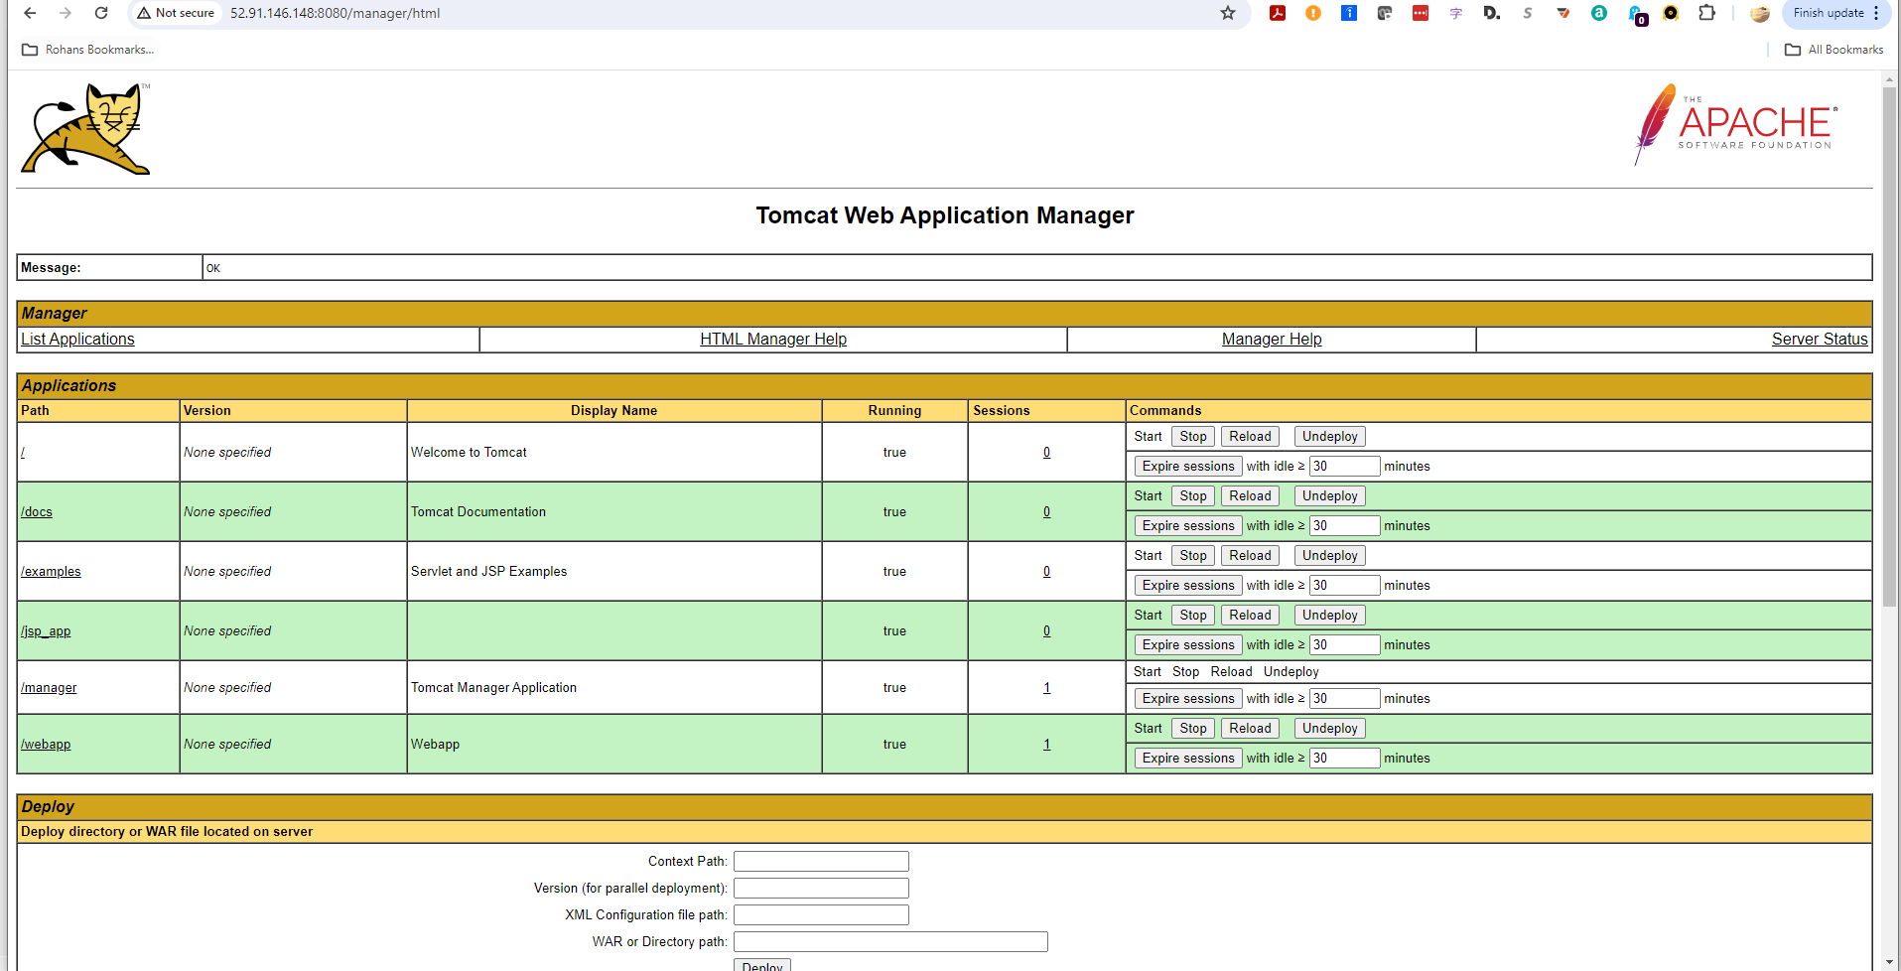
Tomcat Server Linux WAR File Updated on Server.

Tomcat Web UI for WebApp module with popups for Add Product and View Product.
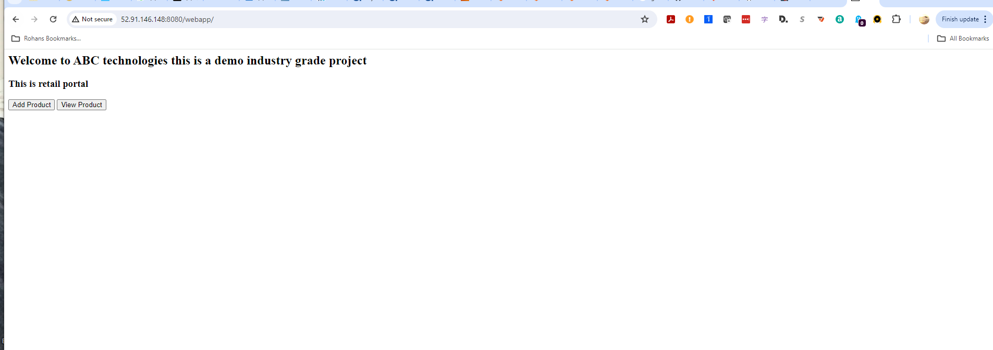

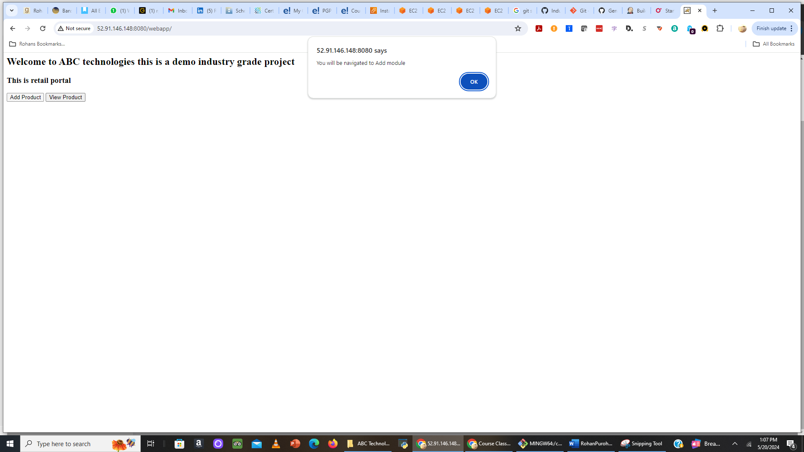

Task 2: Build and Deploy on Docker Container
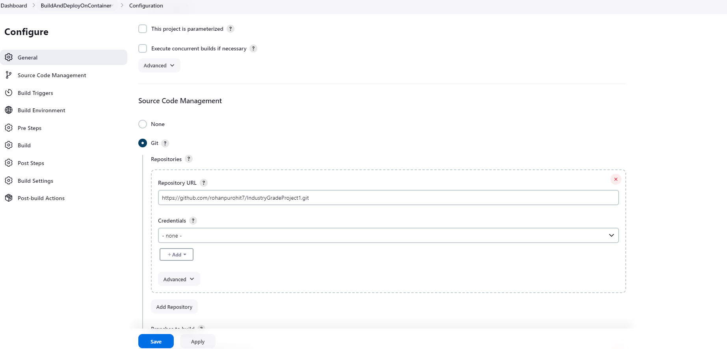

Build Goals Configuration - Clean and Install
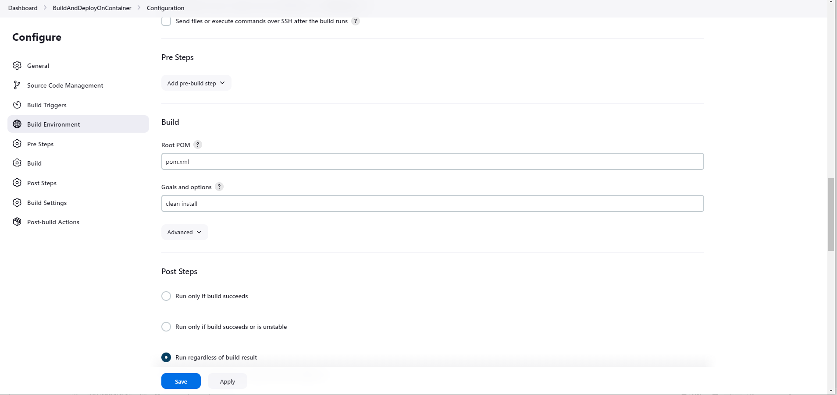

Docker Deployment Commands for app aliased as regappv1
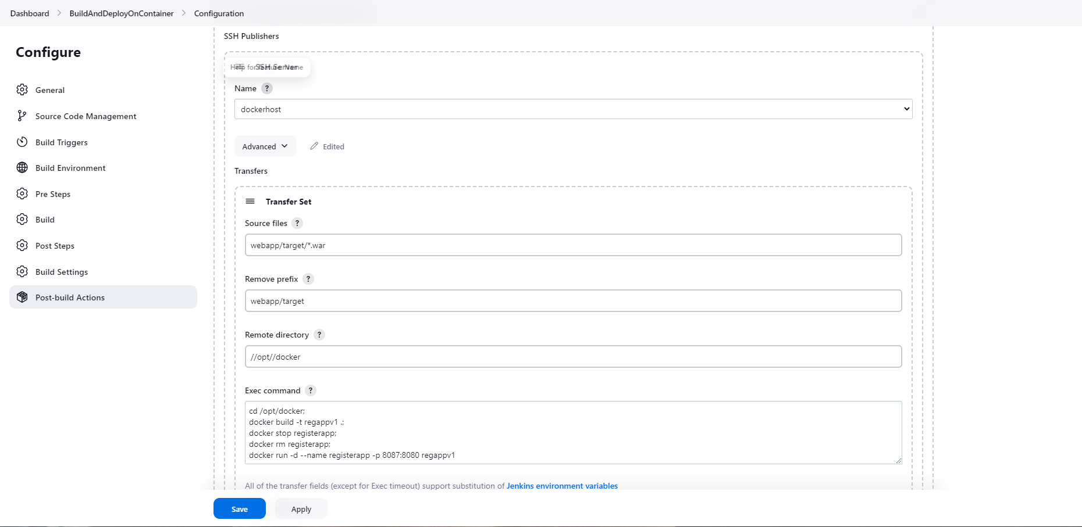

Successful Build and Deploy on Docker Container Log
Started by user Rohan P
Running as SYSTEM
Building in workspace /var/lib/jenkins/workspace/BuildAndDeployOnContainer
The recommended git tool is: NONE
No credentials specified
> git rev-parse --resolve-git-dir /var/lib/jenkins/workspace/BuildAndDeployOnContainer/.git # timeout=10
Fetching changes from the remote Git repository
> git config remote.origin.url https://github.com/rohanpurohit7/IndustryGradeProject1.git # timeout=10
Fetching upstream changes from https://github.com/rohanpurohit7/IndustryGradeProject1.git
> git --version # timeout=10
> git --version # 'git version 2.40.1'
> git fetch --tags --force --progress -- https://github.com/rohanpurohit7/IndustryGradeProject1.git +refs/heads/*:refs/remotes/origin/* # timeout=10
> git rev-parse refs/remotes/origin/master^{commit} # timeout=10
Checking out Revision fed0fe114dc11c8b42298382564c6ead62fb688f (refs/remotes/origin/master)
> git config core.sparsecheckout # timeout=10
> git checkout -f fed0fe114dc11c8b42298382564c6ead62fb688f # timeout=10
Commit message: "pushed changes to pipeline"
First time build. Skipping changelog.
Parsing POMs
Established TCP socket on 33393
[BuildAndDeployOnContainer] $ /usr/lib/jvm/java/bin/java -cp /var/lib/jenkins/plugins/maven-plugin/WEB-INF/lib/maven35-agent-1.14.jar:/opt/maven/boot/plexus-classworlds-2.7.0.jar:/opt/maven/conf/logging jenkins.maven3.agent.Maven35Main /opt/maven /var/cache/jenkins/war/WEB-INF/lib/remoting-3160.vd76b_9ddd10cc.jar /var/lib/jenkins/plugins/maven-plugin/WEB-INF/lib/maven35-interceptor-1.14.jar /var/lib/jenkins/plugins/maven-plugin/WEB-INF/lib/maven3-interceptor-commons-1.14.jar 33393
<===[JENKINS REMOTING CAPACITY]===>channel started
Executing Maven: -B -f /var/lib/jenkins/workspace/BuildAndDeployOnContainer/pom.xml clean install
[INFO] Scanning for projects...
[WARNING]
[WARNING] Some problems were encountered while building the effective model for com.example.maven-project:server:jar:1.0-SNAPSHOT
[WARNING] Reporting configuration should be done in <reporting> section, not in maven-site-plugin <configuration> as reportPlugins parameter.
[WARNING]
[WARNING] Some problems were encountered while building the effective model for com.example.maven-project:webapp:war:1.0-SNAPSHOT
[WARNING] Reporting configuration should be done in <reporting> section, not in maven-site-plugin <configuration> as reportPlugins parameter.
[WARNING]
[WARNING] Some problems were encountered while building the effective model for com.example.maven-project:maven-project:pom:1.0-SNAPSHOT
[WARNING] Reporting configuration should be done in <reporting> section, not in maven-site-plugin <configuration> as reportPlugins parameter. @ line 58, column 24
[WARNING]
[WARNING] It is highly recommended to fix these problems because they threaten the stability of your build.
[WARNING]
[WARNING] For this reason, future Maven versions might no longer support building such malformed projects.
[WARNING]
[WARNING] The project com.example.maven-project:maven-project:pom:1.0-SNAPSHOT uses prerequisites which is only intended for maven-plugin projects but not for non maven-plugin projects. For such purposes you should use the maven-enforcer-plugin. See https://maven.apache.org/enforcer/enforcer-rules/requireMavenVersion.html
[INFO] ------------------------------------------------------------------------
[INFO] Reactor Build Order:
[INFO]
[INFO] Maven Project [pom]
[INFO] Server [jar]
[INFO] Webapp [war]
[INFO]
[INFO] --------------< com.example.maven-project:maven-project >---------------
[INFO] Building Maven Project 1.0-SNAPSHOT [1/3]
[INFO] from pom.xml
[INFO] --------------------------------[ pom ]---------------------------------
[INFO]
[INFO] --- clean:3.2.0:clean (default-clean) @ maven-project ---
[INFO]
[INFO] --- install:3.1.1:install (default-install) @ maven-project ---
[INFO] Installing /var/lib/jenkins/workspace/BuildAndDeployOnContainer/pom.xml to /var/lib/jenkins/.m2/repository/com/example/maven-project/maven-project/1.0-SNAPSHOT/maven-project-1.0-SNAPSHOT.pom
[INFO]
[INFO] ------------------< com.example.maven-project:server >------------------
[INFO] Building Server 1.0-SNAPSHOT [2/3]
[INFO] from server/pom.xml
[INFO] --------------------------------[ jar ]---------------------------------
[INFO]
[INFO] --- clean:3.2.0:clean (default-clean) @ server ---
[INFO] Deleting /var/lib/jenkins/workspace/BuildAndDeployOnContainer/server/target
[INFO]
[INFO] --- resources:2.5:resources (default-resources) @ server ---
[debug] execute contextualize
[INFO] Using 'utf-8' encoding to copy filtered resources.
[INFO] skip non existing resourceDirectory /var/lib/jenkins/workspace/BuildAndDeployOnContainer/server/src/main/resources
[INFO]
[INFO] --- compiler:2.3.2:compile (default-compile) @ server ---
[INFO] Compiling 1 source file to /var/lib/jenkins/workspace/BuildAndDeployOnContainer/server/target/classes
[INFO]
[INFO] --- resources:2.5:testResources (default-testResources) @ server ---
[debug] execute contextualize
[INFO] Using 'utf-8' encoding to copy filtered resources.
[INFO] skip non existing resourceDirectory /var/lib/jenkins/workspace/BuildAndDeployOnContainer/server/src/test/resources
[INFO]
[INFO] --- compiler:2.3.2:testCompile (default-testCompile) @ server ---
[INFO] Compiling 1 source file to /var/lib/jenkins/workspace/BuildAndDeployOnContainer/server/target/test-classes
[INFO]
[INFO] --- surefire:2.11:test (default-test) @ server ---
[INFO] Surefire report directory: /var/lib/jenkins/workspace/BuildAndDeployOnContainer/server/target/surefire-reports

-------------------------------------------------------
T E S T S
-------------------------------------------------------
Running com.example.TestGreeter
Tests run: 2, Failures: 0, Errors: 0, Skipped: 0, Time elapsed: 0.127 sec

Results :

Tests run: 2, Failures: 0, Errors: 0, Skipped: 0

[JENKINS] Recording test results
[INFO]
[INFO] --- jar:3.3.0:jar (default-jar) @ server ---
[INFO] Building jar: /var/lib/jenkins/workspace/BuildAndDeployOnContainer/server/target/server.jar
[INFO]
[INFO] --- install:3.1.1:install (default-install) @ server ---
[INFO] Installing /var/lib/jenkins/workspace/BuildAndDeployOnContainer/server/pom.xml to /var/lib/jenkins/.m2/repository/com/example/maven-project/server/1.0-SNAPSHOT/server-1.0-SNAPSHOT.pom
[INFO] Installing /var/lib/jenkins/workspace/BuildAndDeployOnContainer/server/target/server.jar to /var/lib/jenkins/.m2/repository/com/example/maven-project/server/1.0-SNAPSHOT/server-1.0-SNAPSHOT.jar
[INFO]
[INFO] ------------------< com.example.maven-project:webapp >------------------
[INFO] Building Webapp 1.0-SNAPSHOT [3/3]
[INFO] from webapp/pom.xml
[INFO] --------------------------------[ war ]---------------------------------
[INFO]
[INFO] --- clean:3.2.0:clean (default-clean) @ webapp ---
[INFO] Deleting /var/lib/jenkins/workspace/BuildAndDeployOnContainer/webapp/target
[INFO]
[INFO] --- resources:2.5:resources (default-resources) @ webapp ---
[debug] execute contextualize
[INFO] Using 'utf-8' encoding to copy filtered resources.
[INFO] skip non existing resourceDirectory /var/lib/jenkins/workspace/BuildAndDeployOnContainer/webapp/src/main/resources
[INFO]
[INFO] --- compiler:2.3.2:compile (default-compile) @ webapp ---
[INFO] No sources to compile
[INFO]
[INFO] --- resources:2.5:testResources (default-testResources) @ webapp ---
[debug] execute contextualize
[INFO] Using 'utf-8' encoding to copy filtered resources.
[INFO] skip non existing resourceDirectory /var/lib/jenkins/workspace/BuildAndDeployOnContainer/webapp/src/test/resources
[INFO]
[INFO] --- compiler:2.3.2:testCompile (default-testCompile) @ webapp ---
[INFO] No sources to compile
[INFO]
[INFO] --- surefire:2.11:test (default-test) @ webapp ---
[INFO] No tests to run.
[INFO] Surefire report directory: /var/lib/jenkins/workspace/BuildAndDeployOnContainer/webapp/target/surefire-reports

-------------------------------------------------------
T E S T S
-------------------------------------------------------

Results :

Tests run: 0, Failures: 0, Errors: 0, Skipped: 0

[JENKINS] Recording test results
[INFO]
[INFO] --- war:3.3.2:war (default-war) @ webapp ---
[INFO] Packaging webapp
[INFO] Assembling webapp [webapp] in [/var/lib/jenkins/workspace/BuildAndDeployOnContainer/webapp/target/webapp]
[INFO] Processing war project
[INFO] Copying webapp resources [/var/lib/jenkins/workspace/BuildAndDeployOnContainer/webapp/src/main/webapp]
[INFO] Building war: /var/lib/jenkins/workspace/BuildAndDeployOnContainer/webapp/target/webapp.war
[INFO]
[INFO] --- install:3.1.1:install (default-install) @ webapp ---
[INFO] Installing /var/lib/jenkins/workspace/BuildAndDeployOnContainer/webapp/pom.xml to /var/lib/jenkins/.m2/repository/com/example/maven-project/webapp/1.0-SNAPSHOT/webapp-1.0-SNAPSHOT.pom
[INFO] Installing /var/lib/jenkins/workspace/BuildAndDeployOnContainer/webapp/target/webapp.war to /var/lib/jenkins/.m2/repository/com/example/maven-project/webapp/1.0-SNAPSHOT/webapp-1.0-SNAPSHOT.war
[INFO] ------------------------------------------------------------------------
[INFO] Reactor Summary for Maven Project 1.0-SNAPSHOT:
[INFO]
[INFO] Maven Project ...................................... SUCCESS [ 1.278 s]
[INFO] Server ............................................. SUCCESS [ 5.678 s]
[INFO] Webapp ............................................. SUCCESS [ 2.083 s]
[INFO] ------------------------------------------------------------------------
[INFO] BUILD SUCCESS
[INFO] ------------------------------------------------------------------------
[INFO] Total time: 11.408 s
[INFO] Finished at: 2024-05-20T16:33:46Z
[INFO] ------------------------------------------------------------------------
Waiting for Jenkins to finish collecting data
[JENKINS] Archiving /var/lib/jenkins/workspace/BuildAndDeployOnContainer/webapp/pom.xml to com.example.maven-project/webapp/1.0-SNAPSHOT/webapp-1.0-SNAPSHOT.pom
[JENKINS] Archiving /var/lib/jenkins/workspace/BuildAndDeployOnContainer/webapp/target/webapp.war to com.example.maven-project/webapp/1.0-SNAPSHOT/webapp-1.0-SNAPSHOT.war
[JENKINS] Archiving /var/lib/jenkins/workspace/BuildAndDeployOnContainer/server/pom.xml to com.example.maven-project/server/1.0-SNAPSHOT/server-1.0-SNAPSHOT.pom
[JENKINS] Archiving /var/lib/jenkins/workspace/BuildAndDeployOnContainer/server/target/server.jar to com.example.maven-project/server/1.0-SNAPSHOT/server-1.0-SNAPSHOT.jar
[JENKINS] Archiving /var/lib/jenkins/workspace/BuildAndDeployOnContainer/pom.xml to com.example.maven-project/maven-project/1.0-SNAPSHOT/maven-project-1.0-SNAPSHOT.pom
channel stopped
SSH: Connecting from host [jenkins-server]
SSH: Connecting with configuration [dockerhost] ...
SSH: Creating session: username [dockeradmin], hostname [172.31.4.199], port [22]
SSH: Connecting session ...
SSH: Connected
SSH: Opening SFTP channel ...
SSH: SFTP channel open
SSH: Connecting SFTP channel ...
SSH: Connected
SSH: Remote root is not absolute, getting absolute directory from PWD
SSH: cd [/home/dockeradmin]
SSH: OK
SSH: cd [/opt/docker]
SSH: OK
SSH: put [webapp.war]
SSH: Opening exec channel ...
SSH: EXEC: channel open
SSH: EXEC: STDOUT/STDERR from command [cd /opt/docker;
docker build -t regappv1 .;
docker stop registerapp;
docker rm registerapp;
docker run -d --name registerapp -p 8087:8080 regappv1] ...
SSH: EXEC: connected
#0 building with "default" instance using docker driver

#1 [internal] load build definition from Dockerfile
#1 transferring dockerfile: 224B 0.0s done
#1 DONE 0.0s

#2 [internal] load metadata for docker.io/library/tomcat:latest
#2 DONE 0.0s

#3 [internal] load .dockerignore
#3 transferring context: 2B done
#3 DONE 0.0s

#4 [1/3] FROM docker.io/library/tomcat:latest
#4 CACHED

#5 [internal] load build context
#5 transferring context: 2.41kB done
#5 DONE 0.0s

#6 [2/3] RUN cp -R /usr/local/tomcat/webapps.dist/* /usr/local/tomcat/webapps
#6 DONE 1.4s

#7 [3/3] COPY ./*.war /usr/local/tomcat/webapps
#7 DONE 0.1s

#8 exporting to image
#8 exporting layers 0.1s done
#8 writing image sha256:ff1f3e2b16987eb179f70c72dc13b5cf7d83ceff3091d60a532cbc8ef8b26a0c done
#8 naming to docker.io/library/regappv1 done
#8 DONE 0.2s
Error response from daemon: No such container: registerapp
Error response from daemon: No such container: registerapp
81f3e352d3c1e6183758fe5d7869dcda9adedcfe57963b6d5bf6067ecaebf959
SSH: EXEC: completed after 7,005 ms
SSH: Disconnecting configuration [dockerhost] ...
SSH: Transferred 1 file(s)
Finished: SUCCESS

App WAR file on Docker Host with recent timestamp.
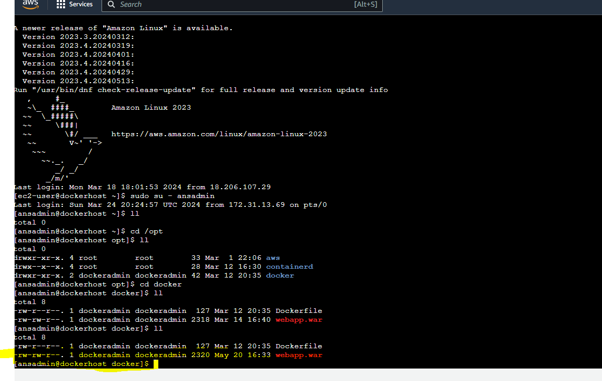

Scripts:

DockerFile Script to source and configure image for Tomcat Container
FROM tomcat:latest
RUN cp -R /usr/local/tomcat/webapps.dist/* /usr/local/tomcat/webapps
COPY ./*.war /usr/local/tomcat/webapps

Create Docker Image Script
---
- hosts: ansible

tasks:
- name: create docker image
command: docker build -t regapp:latest .
args:
chdir: /opt/docker

- name: create tag to push image onto dockerhub repository
command: docker tag regapp:latest shotokan777/regapp:latest

- name: push docker image
command: docker push shotokan777/regapp:latest

~
Deploy Docker Script
---
- hosts: ansible

tasks:
- name: create docker image
command: docker build -t regapp:latest .
args:
chdir: /opt/docker

- name: create tag to push image onto dockerhub repository
command: docker tag regapp:latest shotokan777/regapp:latest

- name: push docker image
command: docker push shotokan777/regapp:latest

Inter Host Networking Hosts File
localhost
[kubernetes]
172.31.17.232
[ansible]
172.31.13.69

Kubernettes Deploy Script

---
- hosts: kubernetes
# become: true
user: root

tasks:
- name: deploy regapp on kubernetes
command: kubectl apply -f regapp-deployment.yml

- name: create service for regapp
command: kubectl apply -f regapp-service.yml

- name: update deployment with new pods if image updated in docker hub
command: kubectl rollout restart deployment.apps/valaxy-regapp

Kubernettes Service Script

---
- hosts: kubernetes
# become: true
user: root

tasks:
- name: deploy regapp on kubernetes
command: kubectl apply -f regapp-service.yml

Reg App Deployment Script

apiVersion: apps/v1
kind: Deployment
metadata:
name: valaxy-regapp
labels:
app: regapp

spec:
replicas: 3
selector:
matchLabels:
app: regapp

template:
metadata:
labels:
app: regapp
spec:
containers:
- name: regapp
image: shotokan777/regapp
imagePullPolicy: Always
ports:
- containerPort: 8080
strategy:
type: RollingUpdate
rollingUpdate:
maxSurge: 1
maxUnavailable: 1

Reg App Service Script

apiVersion: v1
kind: Service
metadata:
name: valaxy-service
labels:
app: regapp
spec:
selector:
app: regapp

ports:
- port: 8080
targetPort: 8080

type: LoadBalancer

Building and Deploying CI on Kubernettes

Build Log
Started by user Bruce P
Running as SYSTEM
Building in workspace /var/lib/jenkins/workspace/RegApp_CI_Job
The recommended git tool is: NONE
No credentials specified
> git rev-parse --resolve-git-dir /var/lib/jenkins/workspace/RegApp_CI_Job/.git # timeout=10
Fetching changes from the remote Git repository
> git config remote.origin.url https://github.com/rohanpurohit7/IndustryGradeProject1.git # timeout=10
Fetching upstream changes from https://github.com/rohanpurohit7/IndustryGradeProject1.git
> git --version # timeout=10
> git --version # 'git version 2.40.1'
> git fetch --tags --force --progress -- https://github.com/rohanpurohit7/IndustryGradeProject1.git +refs/heads/*:refs/remotes/origin/* # timeout=10
> git rev-parse refs/remotes/origin/master^{commit} # timeout=10
Checking out Revision 38c62c4d5e963fccde145c2ce3f052533f73082d (refs/remotes/origin/master)
> git config core.sparsecheckout # timeout=10
> git checkout -f 38c62c4d5e963fccde145c2ce3f052533f73082d # timeout=10
Commit message: "final commit"
First time build. Skipping changelog.
Parsing POMs
Established TCP socket on 42877
[RegApp_CI_Job] $ /usr/lib/jvm/java/bin/java -cp /var/lib/jenkins/plugins/maven-plugin/WEB-INF/lib/maven35-agent-1.14.jar:/opt/maven/boot/plexus-classworlds-2.7.0.jar:/opt/maven/conf/logging jenkins.maven3.agent.Maven35Main /opt/maven /var/cache/jenkins/war/WEB-INF/lib/remoting-3160.vd76b_9ddd10cc.jar /var/lib/jenkins/plugins/maven-plugin/WEB-INF/lib/maven35-interceptor-1.14.jar /var/lib/jenkins/plugins/maven-plugin/WEB-INF/lib/maven3-interceptor-commons-1.14.jar 42877
<===[JENKINS REMOTING CAPACITY]===>channel started
Executing Maven: -B -f /var/lib/jenkins/workspace/RegApp_CI_Job/pom.xml clean install
[INFO] Scanning for projects...
[WARNING]
[WARNING] Some problems were encountered while building the effective model for com.example.maven-project:server:jar:1.0-SNAPSHOT
[WARNING] Reporting configuration should be done in <reporting> section, not in maven-site-plugin <configuration> as reportPlugins parameter.
[WARNING]
[WARNING] Some problems were encountered while building the effective model for com.example.maven-project:webapp:war:1.0-SNAPSHOT
[WARNING] Reporting configuration should be done in <reporting> section, not in maven-site-plugin <configuration> as reportPlugins parameter.
[WARNING]
[WARNING] Some problems were encountered while building the effective model for com.example.maven-project:maven-project:pom:1.0-SNAPSHOT
[WARNING] Reporting configuration should be done in <reporting> section, not in maven-site-plugin <configuration> as reportPlugins parameter. @ line 58, column 24
[WARNING]
[WARNING] It is highly recommended to fix these problems because they threaten the stability of your build.
[WARNING]
[WARNING] For this reason, future Maven versions might no longer support building such malformed projects.
[WARNING]
[WARNING] The project com.example.maven-project:maven-project:pom:1.0-SNAPSHOT uses prerequisites which is only intended for maven-plugin projects but not for non maven-plugin projects. For such purposes you should use the maven-enforcer-plugin. See https://maven.apache.org/enforcer/enforcer-rules/requireMavenVersion.html
[INFO] ------------------------------------------------------------------------
[INFO] Reactor Build Order:
[INFO]
[INFO] Maven Project [pom]
[INFO] Server [jar]
[INFO] Webapp [war]
[INFO]
[INFO] --------------< com.example.maven-project:maven-project >---------------
[INFO] Building Maven Project 1.0-SNAPSHOT [1/3]
[INFO] from pom.xml
[INFO] --------------------------------[ pom ]---------------------------------
[INFO]
[INFO] --- clean:3.2.0:clean (default-clean) @ maven-project ---
[INFO]
[INFO] --- install:3.1.1:install (default-install) @ maven-project ---
[INFO] Installing /var/lib/jenkins/workspace/RegApp_CI_Job/pom.xml to /var/lib/jenkins/.m2/repository/com/example/maven-project/maven-project/1.0-SNAPSHOT/maven-project-1.0-SNAPSHOT.pom
[INFO]
[INFO] ------------------< com.example.maven-project:server >------------------
[INFO] Building Server 1.0-SNAPSHOT [2/3]
[INFO] from server/pom.xml
[INFO] --------------------------------[ jar ]---------------------------------
[INFO]
[INFO] --- clean:3.2.0:clean (default-clean) @ server ---
[INFO] Deleting /var/lib/jenkins/workspace/RegApp_CI_Job/server/target
[INFO]
[INFO] --- resources:2.5:resources (default-resources) @ server ---
[debug] execute contextualize
[INFO] Using 'utf-8' encoding to copy filtered resources.
[INFO] skip non existing resourceDirectory /var/lib/jenkins/workspace/RegApp_CI_Job/server/src/main/resources
[INFO]
[INFO] --- compiler:2.3.2:compile (default-compile) @ server ---
[INFO] Compiling 1 source file to /var/lib/jenkins/workspace/RegApp_CI_Job/server/target/classes
[INFO]
[INFO] --- resources:2.5:testResources (default-testResources) @ server ---
[debug] execute contextualize
[INFO] Using 'utf-8' encoding to copy filtered resources.
[INFO] skip non existing resourceDirectory /var/lib/jenkins/workspace/RegApp_CI_Job/server/src/test/resources
[INFO]
[INFO] --- compiler:2.3.2:testCompile (default-testCompile) @ server ---
[INFO] Compiling 1 source file to /var/lib/jenkins/workspace/RegApp_CI_Job/server/target/test-classes
[INFO]
[INFO] --- surefire:2.11:test (default-test) @ server ---
[INFO] Surefire report directory: /var/lib/jenkins/workspace/RegApp_CI_Job/server/target/surefire-reports

-------------------------------------------------------
T E S T S
-------------------------------------------------------
Running com.example.TestGreeter
Tests run: 2, Failures: 0, Errors: 0, Skipped: 0, Time elapsed: 0.128 sec

Results :

Tests run: 2, Failures: 0, Errors: 0, Skipped: 0

[JENKINS] Recording test results
[INFO]
[INFO] --- jar:3.3.0:jar (default-jar) @ server ---
[INFO] Building jar: /var/lib/jenkins/workspace/RegApp_CI_Job/server/target/server.jar
[INFO]
[INFO] --- install:3.1.1:install (default-install) @ server ---
[INFO] Installing /var/lib/jenkins/workspace/RegApp_CI_Job/server/pom.xml to /var/lib/jenkins/.m2/repository/com/example/maven-project/server/1.0-SNAPSHOT/server-1.0-SNAPSHOT.pom
[INFO] Installing /var/lib/jenkins/workspace/RegApp_CI_Job/server/target/server.jar to /var/lib/jenkins/.m2/repository/com/example/maven-project/server/1.0-SNAPSHOT/server-1.0-SNAPSHOT.jar
[INFO]
[INFO] ------------------< com.example.maven-project:webapp >------------------
[INFO] Building Webapp 1.0-SNAPSHOT [3/3]
[INFO] from webapp/pom.xml
[INFO] --------------------------------[ war ]---------------------------------
[INFO]
[INFO] --- clean:3.2.0:clean (default-clean) @ webapp ---
[INFO] Deleting /var/lib/jenkins/workspace/RegApp_CI_Job/webapp/target
[INFO]
[INFO] --- resources:2.5:resources (default-resources) @ webapp ---
[debug] execute contextualize
[INFO] Using 'utf-8' encoding to copy filtered resources.
[INFO] skip non existing resourceDirectory /var/lib/jenkins/workspace/RegApp_CI_Job/webapp/src/main/resources
[INFO]
[INFO] --- compiler:2.3.2:compile (default-compile) @ webapp ---
[INFO] No sources to compile
[INFO]
[INFO] --- resources:2.5:testResources (default-testResources) @ webapp ---
[debug] execute contextualize
[INFO] Using 'utf-8' encoding to copy filtered resources.
[INFO] skip non existing resourceDirectory /var/lib/jenkins/workspace/RegApp_CI_Job/webapp/src/test/resources
[INFO]
[INFO] --- compiler:2.3.2:testCompile (default-testCompile) @ webapp ---
[INFO] No sources to compile
[INFO]
[INFO] --- surefire:2.11:test (default-test) @ webapp ---
[INFO] No tests to run.
[INFO] Surefire report directory: /var/lib/jenkins/workspace/RegApp_CI_Job/webapp/target/surefire-reports

-------------------------------------------------------
T E S T S
-------------------------------------------------------

Results :

Tests run: 0, Failures: 0, Errors: 0, Skipped: 0

[JENKINS] Recording test results
[INFO]
[INFO] --- war:3.3.2:war (default-war) @ webapp ---
[INFO] Packaging webapp
[INFO] Assembling webapp [webapp] in [/var/lib/jenkins/workspace/RegApp_CI_Job/webapp/target/webapp]
[INFO] Processing war project
[INFO] Copying webapp resources [/var/lib/jenkins/workspace/RegApp_CI_Job/webapp/src/main/webapp]
[INFO] Building war: /var/lib/jenkins/workspace/RegApp_CI_Job/webapp/target/webapp.war
[INFO]
[INFO] --- install:3.1.1:install (default-install) @ webapp ---
[INFO] Installing /var/lib/jenkins/workspace/RegApp_CI_Job/webapp/pom.xml to /var/lib/jenkins/.m2/repository/com/example/maven-project/webapp/1.0-SNAPSHOT/webapp-1.0-SNAPSHOT.pom
[INFO] Installing /var/lib/jenkins/workspace/RegApp_CI_Job/webapp/target/webapp.war to /var/lib/jenkins/.m2/repository/com/example/maven-project/webapp/1.0-SNAPSHOT/webapp-1.0-SNAPSHOT.war
[INFO] ------------------------------------------------------------------------
[INFO] Reactor Summary for Maven Project 1.0-SNAPSHOT:
[INFO]
[INFO] Maven Project ...................................... SUCCESS [ 1.134 s]
[INFO] Server ............................................. SUCCESS [ 5.243 s]
[INFO] Webapp ............................................. SUCCESS [ 2.204 s]
[INFO] ------------------------------------------------------------------------
[INFO] BUILD SUCCESS
[INFO] ------------------------------------------------------------------------
[INFO] Total time: 10.961 s
[INFO] Finished at: 2024-05-20T17:44:12Z
[INFO] ------------------------------------------------------------------------
Waiting for Jenkins to finish collecting data
[JENKINS] Archiving /var/lib/jenkins/workspace/RegApp_CI_Job/webapp/pom.xml to com.example.maven-project/webapp/1.0-SNAPSHOT/webapp-1.0-SNAPSHOT.pom
[JENKINS] Archiving /var/lib/jenkins/workspace/RegApp_CI_Job/webapp/target/webapp.war to com.example.maven-project/webapp/1.0-SNAPSHOT/webapp-1.0-SNAPSHOT.war
[JENKINS] Archiving /var/lib/jenkins/workspace/RegApp_CI_Job/server/pom.xml to com.example.maven-project/server/1.0-SNAPSHOT/server-1.0-SNAPSHOT.pom
[JENKINS] Archiving /var/lib/jenkins/workspace/RegApp_CI_Job/server/target/server.jar to com.example.maven-project/server/1.0-SNAPSHOT/server-1.0-SNAPSHOT.jar
[JENKINS] Archiving /var/lib/jenkins/workspace/RegApp_CI_Job/pom.xml to com.example.maven-project/maven-project/1.0-SNAPSHOT/maven-project-1.0-SNAPSHOT.pom
channel stopped
SSH: Connecting from host [jenkins-server]
SSH: Connecting with configuration [ansible-server] ...
SSH: Creating session: username [ansadmin], hostname [172.31.13.69], port [22]
SSH: Connecting session ...
SSH: Connected
SSH: Opening SFTP channel ...
SSH: SFTP channel open
SSH: Connecting SFTP channel ...
SSH: Connected
SSH: Remote root is not absolute, getting absolute directory from PWD
SSH: cd [/home/ansadmin]
SSH: OK
SSH: cd [/opt/docker]
SSH: OK
SSH: put [webapp.war]
SSH: Opening exec channel ...
SSH: EXEC: channel open
SSH: EXEC: STDOUT/STDERR from command [docker login;
ansible-playbook /opt/docker/create_image_regapp.yml;
sleep 10;

] ...
SSH: EXEC: connected
Authenticating with existing credentials...
WARNING! Your password will be stored unencrypted in /home/ansadmin/.docker/config.json.
Configure a credential helper to remove this warning. See
https://docs.docker.com/engine/reference/commandline/login/#credentials-store

Login Succeeded

PLAY [ansible] *****************************************************************

TASK [Gathering Facts] *********************************************************
[WARNING]: Platform linux on host 172.31.13.69 is using the discovered Python
interpreter at /usr/bin/python3.9, but future installation of another Python
interpreter could change the meaning of that path. See
https://docs.ansible.com/ansible-
core/2.15/reference_appendices/interpreter_discovery.html for more information.
fatal: [~]: UNREACHABLE! => {"changed": false, "msg": "Failed to connect to the host via ssh: ssh: Could not resolve hostname ~: Name or service not known", "unreachable": true}
ok: [172.31.13.69]

TASK [create docker image] *****************************************************
changed: [172.31.13.69]

TASK [create tag to push image onto dockerhub repository] **********************
changed: [172.31.13.69]

TASK [push docker image] *******************************************************
changed: [172.31.13.69]

PLAY RECAP *********************************************************************
172.31.13.69 : ok=4 changed=3 unreachable=0 failed=0 skipped=0 rescued=0 ignored=0
~ : ok=0 changed=0 unreachable=1 failed=0 skipped=0 rescued=0 ignored=0

SSH: EXEC: completed after 40,627 ms
SSH: Disconnecting configuration [ansible-server] ...
SSH: Transferred 1 file(s)
Triggering a new build of RegApp_CD_Job
Finished: SUCCESS

CD Job Log

Kubernettes Web Address for Service and Loadbalancer

